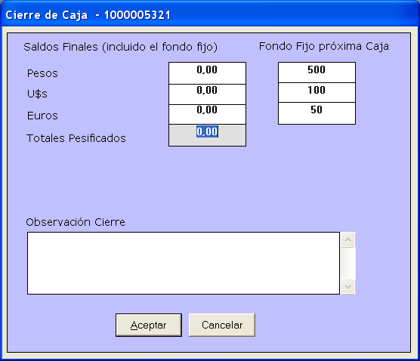
Pesos
Reales
U$S
Euros
Total
Total Sist.
Total Real
800
100
50
20
800
100
50
20

1000

50
20

